The Sixth Sunday after the Epiphany
Morning Prayer Rite II February 12, 2023

Worship Leader: Kitty Underwood
Lector: Neil Hargrave Music Director: Kitty Underwood

Opening Hymn Blessed Jesus, at thy word Hymn 440
From the rising of the sun to its setting my Name shall be great among the nations, and in every place incense shall be offered to my Name, and a pure offering: for my Name shall be great among the nations, says the Lord of hosts. Malachi 1:11

Grace to you and peace from God our Father and from the Lord Jesus Christ. Philippians 1:2

Confession of Sin
Let us confess our sins against God and our neighbor.
Silence may be kept.
Officiant and People together, all kneeling
Most merciful God, we confess that we have sinned against you in thought, word, and deed, by what we have done, and by what we have left undone. We have not loved you with our whole heart; we have not loved our neighbors as ourselves. We are truly sorry and we humbly repent. For the sake of your Son Jesus Christ,
have mercy on us and forgive us; that we may delight in your will, and walk in your ways, to the glory of your Name. Amen.

Almighty God have mercy on us, forgive us all our sins through our Lord Jesus Christ, strengthen us in all
goodness, and by the power of the Holy Spirit keep us in eternal life. Amen.

The Invitatory and Psalter

Officiant | Lord, open our lips.
People | And our mouth shall proclaim your praise.
Glory to the Father, and to the Son, and to the Holy Spirit: as it was in the beginning, is now, and will be for ever. Amen. Alleluia.
The Lord has shown forth his glory: Come let us adore him.
Venite (sung) Psalm 95:1-7 H S-35
Come, let us sing to the Lord; *
let us shout for joy to the Rock of our salvation.
Let us come before his presence with thanksgiving *
and raise a loud shout to him with psalms.
For the Lord is a great God, *
and a great King above all gods.
In his hand are the caverns of the earth, *
and the heights of the hills are his also.
The sea is his, for he made it, *
and his hands have molded the dry land.
Come, let us bow down, and bend the knee, *
and kneel before the Lord our Maker.
For he is our God,
and we are the people of his pasture and the sheep of his hand. *
Oh, that today you would hearken to his voice!
Psalm: 119:1-8 Insert

At the end of the psalm is said:
Glory to the Father, and to the Son, and to the Holy Spirit: as it was in the beginning, is now, and will be for ever. Amen.

The Lessons

First Lesson: Deuteronomy 30:15-20 Insert

Canticle: The first Song of Isaiah H 679
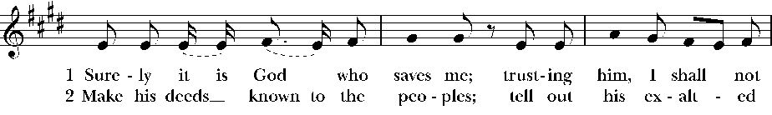
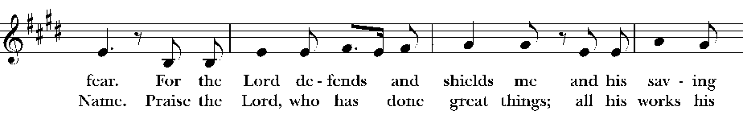
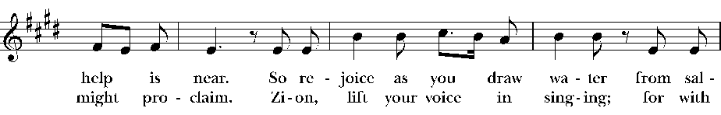
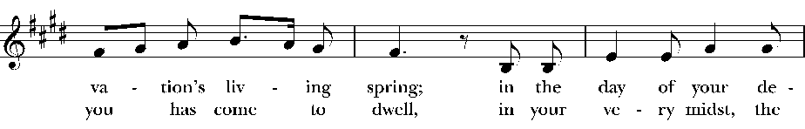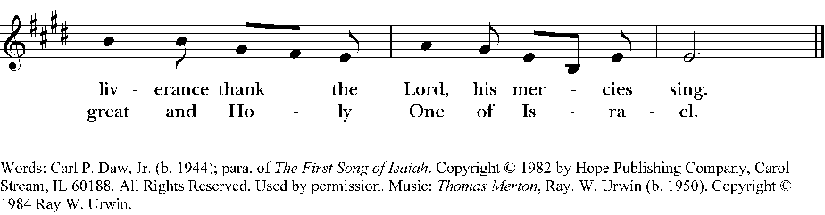

Second Lesson: 1 Corinthians 3:1-9 Insert

Canticle: Glorify thy Name Praise 27
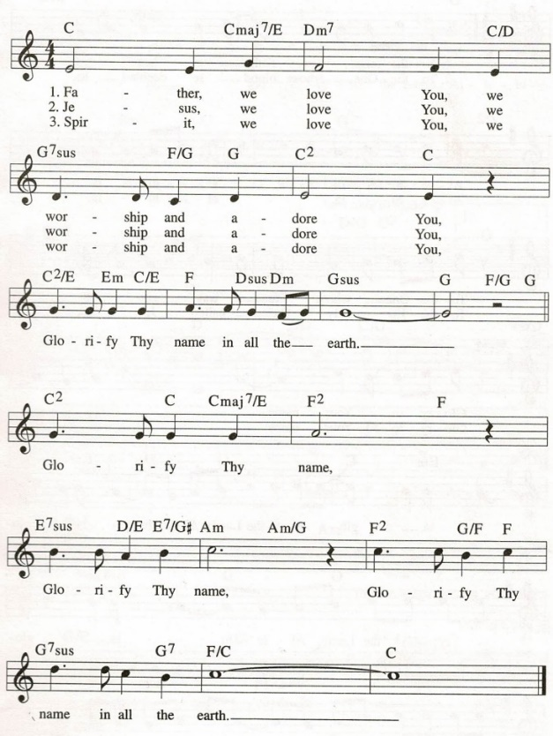

Third Lesson: Matthew 5:21-37 Insert

Sermon: Kitty Underwood
The Apostles' Creed
Officiant and People together, all standing
I believe in God, the Father almighty,
creator of heaven and earth;
I believe in Jesus Christ, his only Son, our Lord.
He was conceived by the power of the Holy Spirit
and born of the Virgin Mary.
He suffered under Pontius Pilate,
was crucified, died, and was buried.
He descended to the dead.
On the third day he rose again.
He ascended into heaven,
and is seated at the right hand of the Father.
He will come again to judge the living and the dead.
I believe in the Holy Spirit,
the holy catholic Church,
the communion of saints,
the forgiveness of sins
the resurrection of the body,
and the life everlasting. Amen.
The Prayers
The People stand or kneel
Officiant | The Lord be with you.
People | And also with you.
Officiant | Let us pray.
Officiant and People
Our Father, who art in heaven,
hallowed be thy Name,
thy kingdom come,
thy will be done,
on earth as it is in heaven.
Give us this day our daily bread.
And forgive us our trespasses,
as we forgive those
who trespass against us.
And lead us not into temptation,
but deliver us from evil.
For thine is the kingdom,
and the power, and the glory,
for ever and ever. Amen.

Suffrages B
V. Save your people, Lord, and bless your inheritance;
R. Govern and uphold them, now and always.
V. Day by day we bless you;
R. We praise your name for ever.
V. Lord, keep us from all sin today;
R. Have mercy upon us, Lord, have mercy.
V. Lord, show us your love and mercy;
R. For we put our trust in you.
V. In you, Lord, is our hope;
R. And we shall never hope in vain.

The Collect of the Day:
O God, the strength of all who put their trust in you: Mercifully accept our prayers; and because in our weakness we can do nothing good without you, give us the help of your grace, that in keeping your commandments we may please you both in will and deed; through Jesus Christ our Lord, who lives and reigns with you and the Holy Spirit, one God, for ever and ever. Amen.

A Collect for Sundays
O God, you make us glad with the weekly remembrance of the glorious resurrection of your Son our Lord: Give us this day such blessing through our worship of you, that the week to come may be spent in your favor; through Jesus Christ our Lord. Amen.

A Collect for the Renewal of Life
O God, the King eternal, whose light divides the day from the night and turns the shadow of death into the morning: Drive far from us all wrong desires, incline our hearts to keep your law, and guide our feet into the way of peace; that, having done your will with cheerfulness during the day, we may, when night comes, rejoice to give you thanks; through Jesus Christ our Lord. Amen.

A Collect for Mission
O God, you have made of one blood all the peoples of the earth, and sent your blessed Son to preach peace to those who are far off and to those who are near: Grant that people everywhere may seek after you and find you; bring the nations into your fold; pour out your Spirit upon all flesh; and hasten the coming of your kingdom; through Jesus Christ our Lord. Amen.

Please see bulletin cover for prayer lists.

We pray for those listed on our Anglican and diocesan cycles of Prayer…

We pray for all who are sick and especially those on our prayer lists…

We pray for those who are unable to be in church…

We pray for those serving in the military…

We pray for the special needs and concerns of this congregation. The people may add their own petitions.

We thank you Lord, for all the blessings of this life. The people may add their own thanksgivings.

We pray for all who have died, that they may have a place in your eternal kingdom. The people may add their own petitons.

Lord Jesus Christ, you said to your apostles, "Peace I give to you; my own peace I leave with you:" Regard not our sins, but the faith of your Church, and give to us the peace and unity of that heavenly City, where with the Father and the Holy Spirit you live and reign, now and for ever. Amen.
The Peace
 | The peace of the Lord be always with you.
People | And also with you.

Announcements, Birthdays, and Anniversaries
Prayers are found in the back of the Book of Common Prayer

The Offertory
Ascribe to the Lord the honor due his Name; bring
offering and come into his courts. Psalm 96:8

Offertory Anthem Forgive our sins, as we forgive Hymn 674

Doxology
Praise God, from whom all blessings flow;
Praise him, all creatures here below;
Praise him above, ye heavenly host;
Praise Father, Son, and Holy Ghost. Amen.

V. All things come of thee, O Lord.
R. And of thine own have we given thee. (1 Chr. 29:14)

The General Thanksgiving

Almighty God, Father of all mercies,
we your unworthy servants give you humble thanks
for all your goodness and loving-kindness
to us and to all whom you have made. We bless you for our creation, preservation, and all the blessings of this life; but above all for your immeasurable love in the redemption of the world by our Lord Jesus Christ; for the means of grace, and for the hope of glory. And, we pray, give us such an awareness of your mercies, that with truly thankful hearts we may show forth your praise, not only with our lips, but in our lives, by giving up our selves to your service, and by walking before you in holiness and righteousness all our days; through Jesus Christ our Lord, to whom, with you and the Holy Spirit, be honor and glory throughout all ages. Amen.

A Prayer of St. Chrysostom

Almighty God, you have given us grace at this time with one accord to make our common supplication to you; and you have promised through your well-beloved Son that when two or three are gathered together in his Name you will be in the midst of them: Fulfill now, O Lord, our desires and petitions as may be best for us; granting us in this world knowledge of your truth, and in the age to come life everlasting. Amen.

Let us bless the Lord.
Thanks be to God.

The grace of our Lord Jesus Christ, and the love of God, and the fellowship of the Holy Spirit, be with us all evermore. Amen. 2 Corinthians 13:14

Closing Hymn: I come with joy to meet my Lord Hymn 304
+++++++++++++++++++++++++++++++++++++++++++++++++++++
Liturgical note – Tomorrow is the feast of Absalom Jones. Absalom Jones was born on November 6, 1746, a house slave in Delaware. He taught himself to read out of the New Testament, among other books. Jones bought his freedom in 1784. At St. George’s Methodist Episcopal Church, he served as lay minister for its black membership. The active evangelism of Jones and that of his friend, Richard Allen, greatly increased black membership at St. George’s.
The alarmed vestry decided to segregate blacks into an upstairs gallery, without notifying them. During a Sunday service when ushers attempted to remove them, the blacks indignantly walked out as a body. In 1787, black Christians organized the Free African Society, the first organized Afro-American society, and Absalom Jones and Richard Allen were elected overseers. In October 1794 their church was admitted to the Episcopal Diocese of Pennsylvania as St. Thomas African Episcopal Church. Bishop White ordained Jones as deacon in 1795 and as priest on September 21, 1802.
Jones was an earnest preacher. He denounced slavery, and warned the oppressors to “clean their hands of slaves.” But it was his constant visiting and mild manner that made him beloved by his own flock and by the community. St. Thomas Church, Philadelphia, grew to over 500 members during its first year. Known as “the Black Bishop of the Episcopal Church,” Jones was an example of persistent faith in God and in the church as God’s instrument. Jones died on February 13th, 1818, in Philadelphia.

The Sixth Sunday after the Epiphany, Year A

Deuteronomy 30:15-20
See, I have set before you today life and prosperity, death and adversity. If you obey the commandments of the LORD your God that I am commanding you today, by loving the LORD your God, walking in his ways, and observing his commandments, decrees, and ordinances, then you shall live and become numerous, and the LORD your God will bless you in the land that you are entering to possess. But if your heart turns away and you do not hear, but are led astray to bow down to other gods and serve them, I declare to you today that you shall perish; you shall not live long in the land that you are crossing the Jordan to enter and possess. I call heaven and earth to witness against you today that I have set before you life and death, blessings and curses. Choose life so that you and your descendants may live, loving the LORD your God, obeying him, and holding fast to him; for that means life to you and length of days, so that you may live in the land that the LORD swore to give to your ancestors, to Abraham, to Isaac, and to Jacob.
Psalm 119:1-8
1 Happy are those whose way is blameless, who walk in the law of the LORD.
2 Happy are those who keep his decrees, who seek him with their whole heart,
3 who also do no wrong, but walk in his ways.
4 You have commanded your precepts to be kept diligently.
5 O that my ways may be steadfast in keeping your statutes!
6 Then I shall not be put to shame, having my eyes fixed on all your commandments.
7 I will praise you with an upright heart, when I learn your righteous ordinances.
8 I will observe your statutes; do not utterly forsake me.
1 Corinthians 3:1-9
And so, brothers and sisters, I could not speak to you as spiritual people, but rather as people of the flesh, as infants in Christ. I fed you with milk, not solid food, for you were not ready for solid food. Even now you are still not ready, for you are still of the flesh. For as long as there is jealousy and quarreling among you, are you not of the flesh, and behaving according to human inclinations? For when one says, "I belong to Paul," and another, "I belong to Apollos," are you not merely human? What then is Apollos? What is Paul? Servants through whom you came to believe, as the Lord assigned to each. I planted, Apollos watered, but God gave the growth. So neither the one who plants nor the one who waters is anything, but only God who gives the growth. The one who plants and the one who waters have a common purpose, and each will receive wages according to the labor of each. For we are God's servants, working together; you are God's field, God's building.
Matthew 5:21-37
"You have heard that it was said to those of ancient times, 'You shall not murder'; and 'whoever murders shall be liable to judgment.' But I say to you that if you are angry with a brother or sister, you will be liable to judgment; and if you insult a brother or sister, you will be liable to the council; and if you say, 'You fool,' you will be liable to the hell of fire. So when you are offering your gift at the altar, if you remember that your brother or sister has something against you, leave your gift there before the altar and go; first be reconciled to your brother or sister, and then come and offer your gift. Come to terms quickly with your accuser while you are on the way to court with him, or your accuser may hand you over to the judge, and the judge to the guard, and you will be thrown into prison. Truly I tell you, you will never get out until you have paid the last penny. "You have heard that it was said, 'You shall not commit adultery. But I say to you that everyone who looks at a woman with lust has already committed adultery with her in his heart. If your right eye causes you to sin, tear it out and throw it away; it is better for you to lose one of your members than for your whole body to be thrown into hell. And if your right hand causes you to sin, cut it off and throw it away; it is better for you to lose one of your members than for your whole body to go into hell. "It was also said, 'Whoever divorces his wife, let him give her a certificate of divorce.' But I say to you that anyone who divorces his wife, except on the ground of unchastity, causes her to commit adultery; and whoever marries a divorced woman commits adultery. "Again, you have heard that it was said to those of ancient times, 'You shall not swear falsely, but carry out the vows you have made to the Lord.' But I say to you, Do not swear at all, either by heaven, for it is the throne of God, or by the earth, for it is his footstool, or by Jerusalem, for it is the city of the great King. And do not swear by your head, for you cannot make one hair white or black. Let your word be 'Yes, Yes' or 'No, No'; anything more than this comes from the evil one.

